Frog Dissection Lab Names: _________________ Date: _________ Class: __

Purpose:
The purpose of the lab is to observe the internal structures (cells, tissues, organs and organ systems) of a frog‘s anatomy, determine the function of those internal structures, and compare them to the internal structures of the human body systems. .

Materials:
Frog Dissection reference guide, dissecting tray, forceps, scissors, dissection pins, probe, frog, googles, gloves

Key Terms and Pronunciation
nictitating (nick-tih-tay-ting) eustachian (you-stay-kee-un) glottis (glot-iss)
tympanum (tim-pan-num) cloacal (kloh-a-kull) nare
laryngotrachea (larr-in-joe-tray-key-ah)

Experimental Design: You will be dissecting a Leopard Frog – a frog very common to much of North America. Though frogs are much simpler than humans, they have all of the same organ systems that we do and their digestive system is arranged in a very similar manner to ours. During this lab activity you will be observing external features, mouth, digestive system, heart, lungs and respiratory system and reproductive system.
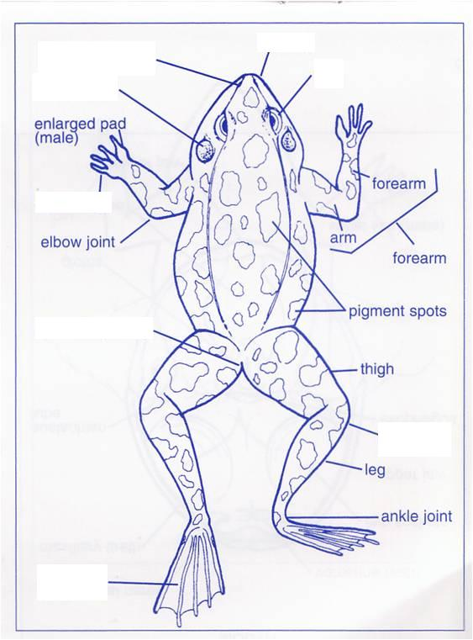
External Structures of the Frog

Part A: Head
- The internal nares open into the:
  - mouth
  - cloaca
  - stomach
  - esophagus

- The tympanum is the:
  - eyelid
  - eardrum
  - nostril
  - cloacal aperture

- The nictitating membrane is an extension of the:
  - lower eyelid
  - upper eyelid
  - eardrum
  - tongue

- The frog lacks __________ on its head.
  - external ears
  - nostrils
  - eyes
  - upper eyelids

- Locate the frog's eyes. The nictitating membrane is a clear membrane that attached to the bottom of the eye. Use tweezers to carefully remove the nictitating membrane. You may also remove the eyeball.

- What color is the nictitating membrane?
_____________________________________ Figure 1: External Structure of the Frog
- What color is the eyeball? ________________
- Just behind the eyes on the frog's head is a circular structure called the tympanic membrane. The tympanic membrane is used for hearing. Measure the diameter (distance across the circle) of the tympanic membrane. Diameter of tympanic membrane _______cm
- Extend a probe through the nostrils to see where the probes exists inside the mouth. Why are the nostrils located at the highest point on the frog’s head? ____________________________________
_________________________________________________________________________________

Part B: Trunk, Appendages, and Skin

- Observe the dorsal (back) and ventral (belly) sides of the frog.
Dorsal side colour ___________________ Ventral side colour _________________
- Feel the frog’s skin. Is it scaly or is it slimy? ___________
- Examine the hind legs. Measure the length of the hind legs: ____________ cm
How many digits (toes) are present on each foot? ________
Are the toes webbed? _________
- Examine the forelegs. Measure the length of the forelegs: ____________ cm
How many digits (toes) are present on each foot? ________
Are the toes webbed? _________

Part C: Mouth
- Locate the tongue. Play with the tongue. Does it attach to the front or the back of the mouth? ______________________________ (You may remove the tongue.)
- Why is the tongue attached at the front of the frog’s mouth? ____________________________________
___________________________________________________________________________________
- In the center of the mouth, toward the back is a single round opening. This is the esophagus. This tube leads to the stomach. Use a probe to poke into the esophagus.
- Close to the angles of the jaw are two openings, one on each side. These are the Eustachian tubes. They are used to equalize pressure in the inner ear while the frog is swimming. Insert a probe into the Eustachian tube. To what structure does the Eustachian tube attach? __________________________
- Just behind the tongue and before you reach the esophagus is a slit like opening. (You may need to use your probe to get it to open up). This slit is the glottis, and it is the opening to the lungs. The frog breathes and vocalizes with the glottis.
- The frog has two sets of teeth. The vomerine teeth are found on the roof of the mouth and are pointed inward to prevent escape of prey. The maxillary teeth are found around the edge of the mouth and are used for gripping only. Essentially, both are used for holding prey, frogs swallow their meals whole and do NOT chew.
- On the roof of the mouth, you will find two tiny openings, if you put your probe into those openings, you will find they exit on the outside of the frog. These are the nares.

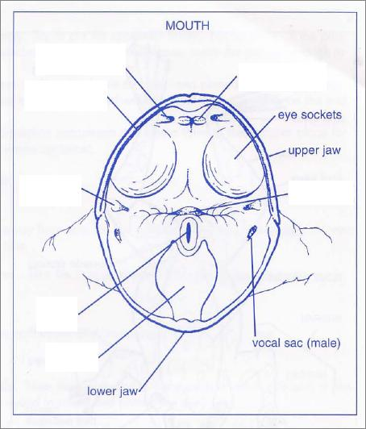
- Label the diagram of the mouth of the frog.
- The forelegs of the frog are _____ the hind legs.
  - shorter than
  - the same length as
  - longer than

- Five functional digits are found on the:
  - forelegs only
  - hind legs only
  - both forelegs and hind legs

- The cloacal aperture (opening) is found:
  - in the mouth
  - in the nares
  - under the eardrum
  - at the tail

- The hind leg is primarily for:
  - support
  - locomotion
  - clasping the female in reproduction
  - none of these

Internal Structures of the Frog Figure 2: Frog mouth interior

Part A: Circulation and Respiration
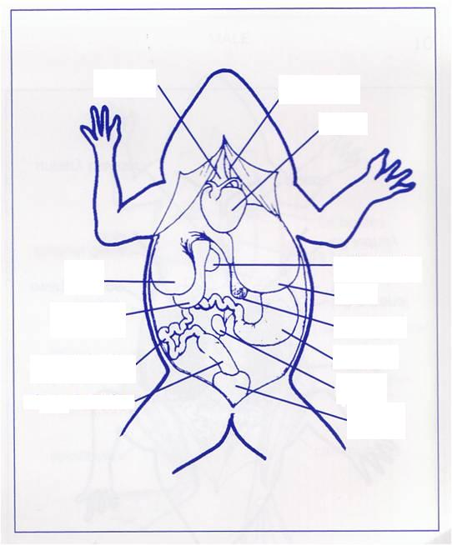
- Label the diagram of frog internal structures.
- The organ that has two atria and one
ventricle is the:
  - kidney
  - heart
  - lung
  - liver

- The following are parts of the frog’s
respiratory system except the:
  - laryngotrachea
  - esophagus
  - lung
  - bronchi

- The following are parts of the frog’s
circulatory system except the:
  - conus arteriosus (artery in heart)
  - ventricle
  - atrium
  - glottis

- The small round sack attached to the liver
is the:
  - spleen
  - gall bladder
  - pancreas
  - cloaca

Figure 3: Frog internal structures

Part B: Digestion
Removal of the Stomach: Cut the stomach out of the frog and open it up. You may find what remains of the frog's last meal in there. Look at the texture of the stomach on the inside.
What did you find in the stomach? ___________________________________________________
Measuring the Small intestine: Remove the small intestine from the body cavity and carefully. Separate the mesentery (tissue on small intestine) from it. What is the purpose of the mesentery? ______________________ _________________________________________________________________________________________
Stretch the small intestine out and measure it. Now measure your frog. Record the measurements below in centimeters. Frog length: _______ cm Small Intestine length ________ cm
Part C: Excretion and Reproduction
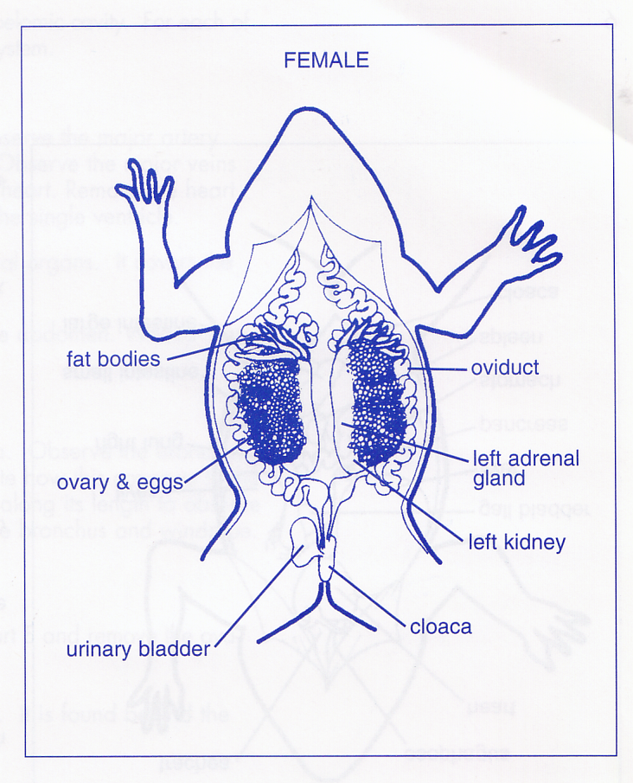
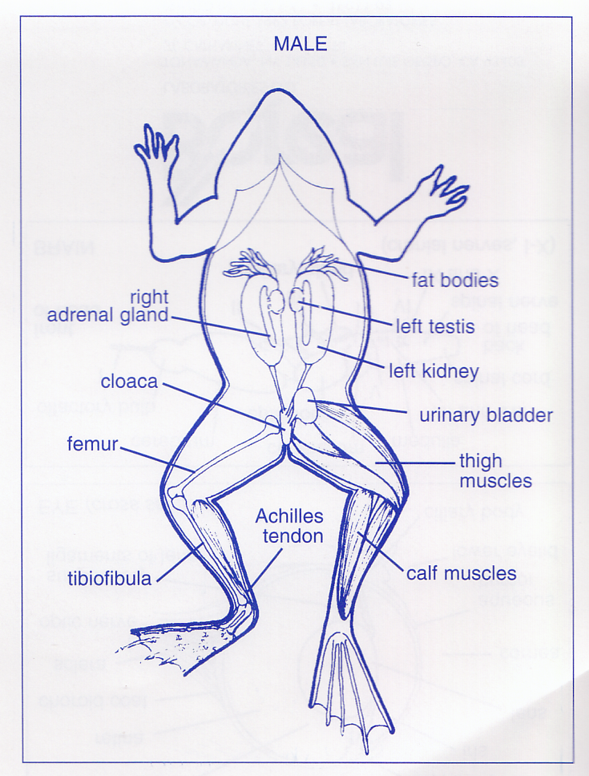
Urogenital System - The frog's reproductive and excretory system is combined into one system called the urogenital system. You will need to know the structures for both the male and female frog.

- The cloaca receives all of the following except:
  - bile b. urine c. digestive waste d. sperm

- Sperm are produced by the:
  - ovaries b. kidneys c. urinary bladder d. testes
Analysis and Conclusion Questions
Answer all questions listed in complete sentences.

- Use a magnifying glass to look at the stomach’s muscular walls. What are the interior stomach contents? What is the appearance of the stomach surface? What is the function of the interior stomach surface?

__________________________________________________________________________________________________

__________________________________________________________________________________________________

__________________________________________________________________________________________________

__________________________________________________________________________________________________

__________________________________________________________________________________________________

- Observe how the frog’s heart is different from a human heart. What are 3 these visible differences? How many chambers are there in the frog’s heart? How many larger blood vessels are attached to the frog’s heart?

__________________________________________________________________________________________________

__________________________________________________________________________________________________

__________________________________________________________________________________________________

__________________________________________________________________________________________________

__________________________________________________________________________________________________

- Where is the pancreas and what doe it look like? Where is the liver and what does it look like? Where is gall bladder and what does it look like? Where is the heart and what does it look like? Where are the lungs and what do they look like?

__________________________________________________________________________________________________

__________________________________________________________________________________________________

__________________________________________________________________________________________________

__________________________________________________________________________________________________

__________________________________________________________________________________________________

- How do frogs eat? What is the role of the tongue? What is the role of the teeth? What is the role of the pharynx?

__________________________________________________________________________________________________

__________________________________________________________________________________________________

__________________________________________________________________________________________________

__________________________________________________________________________________________________

___________________________________________________________________________________________________________________________

