Key Term | Definition-In Your Own Words | Memory Cue
Semi-permeable | allows passage of only certain types of molecules by active and passive transport. | +/-  “gate keeper”
Passive transport | movement of particles across a cell membrane without using energy. | High to Low  No ATP
Diffusion | movement of molecules from high concentrations to low concentrations; a type of passive transport (air or gases) | High to Low  “Room spray”
Osmosis | the diffusion of water through a semi-permeable membrane or cell membrane; a type of passive transport. | High to low  “food color in water”
Active transport | Movement of particles across the cell membrane USING Energy. | Low to High  Use ATP
Vesicle | membrane-bound sacs that function in storage and transport of particles | Made by ER
Endocytosis | Active Transport: process where a cell uses energy to surround a particle with cell membrane; enclose the particle in a vesicle and bring it inside the ce | 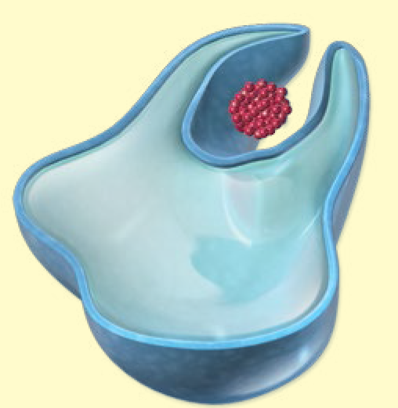
Exocytosis | Active Transport: process where a cell uses energy to enclose particles in a vesicle and released from a cell; vesicle fuses to the cell membrane and are released outside of the cell. | Opposite of endocytosis
Photosynthesis | process by which plants, algae, and some bacteria make their own food by take Carbon dioxide + water with SUNLIGHT to make sugar/glucose | chloroplast  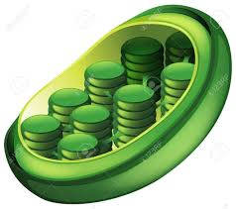
Cellular respiration | process by which cells use oxygen to produce energy (ATP) from food. | mitochondria  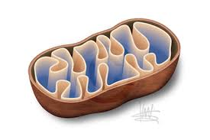
Chlorophyll | green pigment found in the chloroplasts used to absorb light to help in the process of photosynthesis. | “green color”
Glucose | A sugar molecule that is a major energy source (ATP) for most cells, made by pants in the process of photosynthesis. | carbohydrate
ATP or (adenosine triphosphate) | An energy carrying molecule within cells that is the main energy currency of the cell. | *all living thing use energy*
Cell cycle | The normal sequence of growth, maintenance, and division in a cell. | Mitosis IPMAT, cytokinesis
Mitosis | the process where a cells’ DNA copied are sorted into what will become two new cells.; a cell divides, resulting in two identical cells. | 2n 2 n  2n
Chromosome | DNA is packaged or “wound up” for Cell Division. | 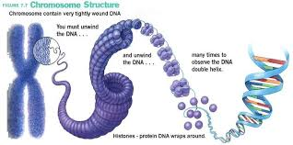
Molecule p.90 | a group of atoms that are held together by chemical bonds; materials in cells are made up of atoms that can join together to form molecule. | Living & non-living  (water H-O-O)

What do I already know? Relate cell structure to cell function (specifically: cell membrane, nucleus, chloroplasts, cytoplasm, lysosome and mitochondria.

